# IPO Chart

| Input | Process | Output |
| --- | --- | --- |
| Hours,  Rate | 1. Determine gross pay, checking for Overtime 2. Calculate Federal taxes based on Gross Pay 3. Calculate SS Taxes based on Gross Pay 4. Calculate net pay | Federal Taxes, SS Taxes, Gross Pay, Net Pay |

# Flow Chart

[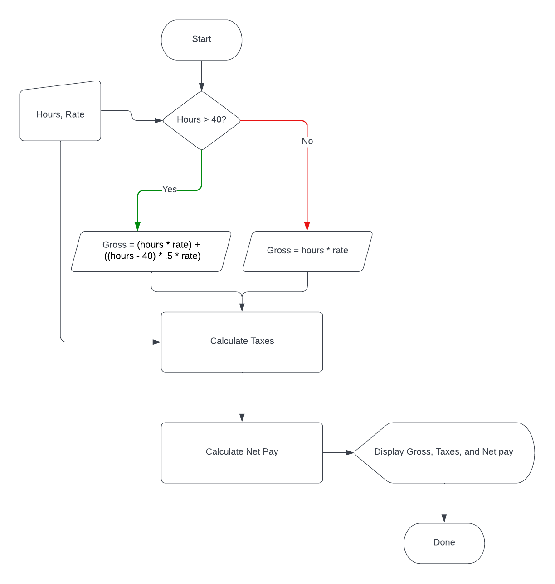](https://lucid.app/documents/edit/1faafac3-caf3-4057-8adf-f01fbece2c5d/0?callback=close&name=docs&callback_type=back&v=490&s=612)

# Pseudo-Code

hours as decimal

rate as decimal

gross as decimal

net as decimal //gross - federal - ss

taxes as decimal

federalTaxes as decimal

socialSecurityTaxes as decimal

federalTaxRate = .18

socialSecurityTaxRate = .0765

if hours>40 then

//time and a half: in addition to the employee's standard hourly rate, they

// will get paid an additional one half of that rate for each hour worked in

// the time and a half window.

gross = (hours * rate) + ((hours - 40) * .5 * rate)

else

gross = (hours * rate)

end if

//taxes get rounded to nearest whole cent in most states and situations

federalTaxes = gross * federalTaxRate //rounding to nearest dollar socialSecurityTaxes = gross * socialSecurityTaxRate //rounding to nearest dollar

taxes = federalTaxes + socialSecurityTaxes

net = gross - taxes

# Test Cases

## 38 hours at $10

hours = 38

rate = 10

gross = 38 * 10 = 380

federalTaxes = 380 * .18 = 68.4

socialSecurityTaxes = 380 * .0765 = 29.07

taxes = 68.4 + 29.07 = 97.47

net = 380 - 97.47 = **282.53**

## 45 hours at $40

//gets time and a half

hours = 45

rate = 10

gross = (45 * 10) + ((45-40) * .5 * 10) = 450 + (5 * .5 * 10) = 450 + 25 = 475

federalTaxes = 475 * .18 = 85.5

socialSecurityTaxes = 475 * .0765 = 36.3375 //round to 36.34

taxes = 85.5 + 36.34 = 121.84

net = 475 - 121.84 = **353.16**